**Greater Sydney, Place and Infrastructure** IRF19/6661

Gateway determination report

|  |  |
| --- | --- |
| **LGA** | Fairfield |
| **PPA** | Fairfield City Council |
| **NAME** | Fairfield Forum (1,489 dwellings) |
| **NUMBER** | PP_2019_FAIRF_002_00 |
| **LEP TO BE AMENDED** | Fairfield Local Environmental Plan 2013 |
| **ADDRESS** | 8-36 Station Street, Fairfield |
| **DESCRIPTION** | Lot 1031 DP 1049068 |
| **RECEIVED** | 15 October 2019, additional information received on 27 November 2019 and 18 February 2020. |
| **FILE NO.** | EF19/27918 |
| **POLITICAL DONATIONS** | There are no donations or gifts to disclose and a political donation disclosure is not required. |
| **LOBBYIST CODE OF CONDUCT** | There have been no meetings or communications with registered lobbyists with respect to this proposal. |

**1. INTRODUCTION**

**1.1 Description of planning proposal**

The planning proposal **(Attachment A2)** seeks to make changes to the development controls applying to a large site known as the Fairfield Forum, located at 8-36 Station Street, Fairfield, to facilitate a vibrant mixed-use centre, including a range of residential, commercial, community and recreational uses.

The planning proposal seeks to enable 1,489 dwellings, 17,600m² of new retail gross floor space and up to 2,919 carparking spaces by:

* increasing the current FSR control from 2.5:1 to 3.5:1;
* increasing the existing height of building control from 26m (8 storeys) to 82m (25 storeys); and
* providing 4,000m² of public open space; a market square; and, new pedestrian linkages throughout the site.

The proposal will not reduce retail uses on the site but seeks to revitalise this use by introducing new types of retail uses, including fine grain retail and food and drink premises that provide activation of new public spaces within the site.

**1.2 Site description**

The planning proposal applies to 8-36 Station Street, Fairfield (Figure 1). The site forms the north-western boundary of the Fairfield Town Centre and is located approximately 450m from Fairfield Railway Station.

The site is approximately 4.3ha in area and consists of the Fairfield Forum retail mall, with more than 50 retail stores, having an area of approximately 17,800m² over two floors. Fairfield Forum is anchored by K Mart, Coles and Aldi stores. The site has access to three street frontages along Station Street, Cunninghame Street and Ware Street.

The site is within Fairfield Town Centre, the largest centre in the LGA. The majority of the town centre is to the north of Fairfield Railway Station. Fairfield Forum is one of two shopping centres in the town centre. Together with Neeta City Shopping Centre, the combined retail space of the two shopping centres is approximately 43,000m² (Figure 1).

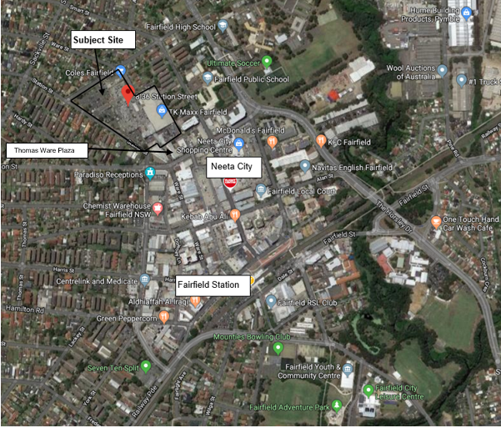

Figure 1 – Location map

Fairfield Forum is anchored by Kmart, Coles and Aldi supermarkets and Neeta City Shopping Centre is anchored by a Big W and Woolworths supermarket. The remainder of the Fairfield Town Centre includes a range of local and independent commercial tenants.

Across Cunninghame Street to north of the site is R3 Medium Residential Density zoned land with mostly single-storey detached dwellings. This precinct is subject to a planning proposal (PP_2015_FAIRF_003_01) for rezoning to R4 High Density Residential zone to allow 20m (6 storeys) heights.

The land to the east across Ware Street is zoned R4 High Density Residential and characterised by low density residential dwellings dominated by detached fibro cottages. Across Smart Street to the site is residential development of two to six storeys with rear boundaries adjoining the subject site.

The southern side of the site is the Fairfield Town Centre, which is zoned B4 Mixed Use - with a mix of commercial, retail and residential developments of six to eight storeys. The land to the west, across Station Street, is zoned R4 and comprises of dwelling houses; a place or public worship; an educational establishment; and, medical/dental practices.

**1.3 Existing planning controls**

The site is zoned B4 Mixed Use under the Fairfield LEP 2013 (Figure 2). No changes are proposed to the zoning. The zone allows residential flat buildings, shop top housing and commercial premises including retail uses. The permissible building height on the site is 26m and the FSR is 2.5:1.

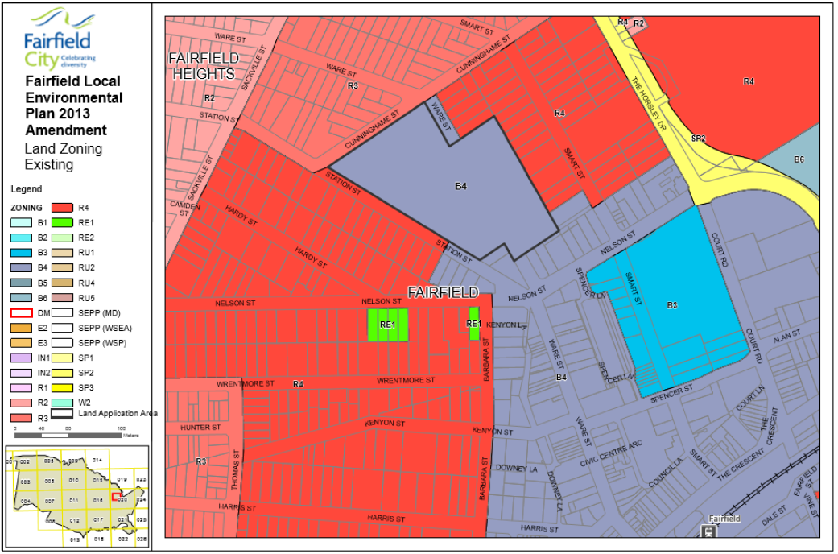

Figure 2 – Existing zoning map

**1.4 Summary of recommendation**

It is recommended that the planning proposal proceed subject to conditions as it will:

* facilitate revitalisation of a strategic centre and provide additional housing and jobs near public transport (railway stations and buses) and community facilities;
* support a 30-minute city vision of the Western City District Plan by providing housing and jobs within 10-minute walk from a public transport interchange;
* revitalise retail outlets by introducing new type of retail uses, including fine grain retail and food and drink premises;
* increase housing diversity and deliver a built form and urban design outcomes with a series of through site links and new open spaces including a new 4000m² public open space; and
* not result in the loss of net employment within the precinct.

**2. PROPOSAL**

**2.1 Objectives or intended outcomes**

The main objective of the planning proposal is to support the revitalisation of Fairfield Town Centre. It will facilitate the redevelopment of an underutilised site, in single ownership, into a vibrant mixed-use centre supporting a range of residential, commercial, community and recreational uses.

**2.2 Explanation of provisions**

The planning proposal seeks to amend the Fairfield LEP 2013 by amending:

* the Height of Buildings Map (HOB_20), to increase the permissible height from 26m (8 storeys) to 82m (25 storeys); and
* the Floor Space Ratio Map (FSR_20), to increase the FSR from 2.5:1 to 3.5:1.

The planning proposal will provide:

* 1,489 residential units ranging from 5 to 25 storeys (Figure 3);
* 17,600m² of retail floor space with a market square concept and increased pedestrian movements through the site;
* 2,919 car parking spaces;
* a new road connection through the site linking Ware Street with Station Street; and
* 7,900m² open space including a 4,000m² public park at the corner of Station and Cunninghame Streets.

The planning proposal is supported by urban design, flood, landscape, traffic and parking studies.

To facilitate the orderly development of the site, the proposed masterplan envisages a phasing strategy to allow delivery of the key components of the development. The Mixed Use and Retail Hubs, Ware Street Plaza extension, as well as, retail basement carpark within the southern part of the site - are among the first phase of the development to be constructed. The public park and the residential towers addressing the public park within the northern part are identified amongst the last phase of the development.

Council advises while the planning proposal does not propose rezoning land for a public park at this stage, a separate planning proposal will be prepared to rezone the proposed 4,000m² public park to RE1 Public Recreation, once the park is established and dedicated to Council.

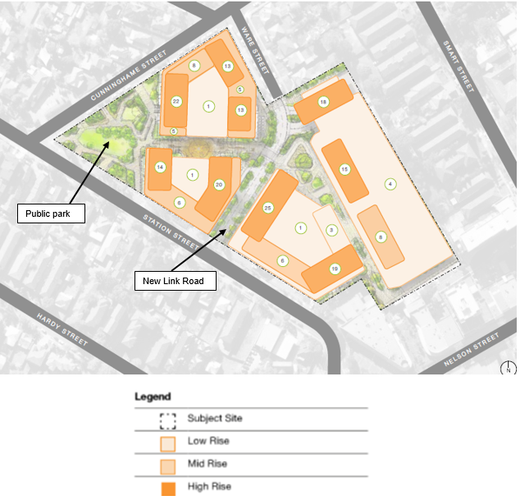

Figure 3 – Indicative Concept Plan

Development Control Plan

Council advises that the indicative layout plan (Figure 3) in the Masterplan and Urban Design Analysis **(Attachment E)** has been developed by the proponent (Harrington Custodian Pty Ltd) through extensive consultation and workshops with council officers and Council’s relevant teams, including specialist urban design consultants. The broader vision of the masterplan is to create a series of spaces and opportunities for an engaging public realm, along with a high degree of individual residential amenity. The new mixed-use precinct is aimed to activate the Fairfield Town Centre, while creating a lively neighbourhood for residents.

Council resolved to prepare a site-specific Development Control Plan (DCP) for the site following the receipt of a Gateway determination. Council’s report notes that the DCP should consider the following:

* locate retaining activities at the southern end of the site;
* the creation of additional pedestrian linkages to the other retail hubs as well as provision of vehicular and pedestrian connections through the site by way of a new road that extends Ware Street to Station Street;
* requirements for ground floor/street activation and identification of areas where retail/commercial floor space should be located;
* not prejudice the possible future redevelopment of adjoining sites;
* not overshadow public domain or adjoining properties between 9am-3pm on 21 June any greater than that expected if the site was developed under the controls set out in Section 4 – Land Use and Building Envelope Control of the existing Fairfield City Council DCP;
* consideration of provision relating to Crime Prevention Through Environmental Design; and
* consideration of Water Sensitive Urban Design principles.

Council also requires that the DCP be informed by:

* a detailed traffic assessment including intersection capacities under existing and future conditions;
* an updated flood study utilising overland and mainstream flood levels recently completed by Council.

**Department comment:** The Department agrees that Council should prepare a draft site-specific DCP for the site and this should be concurrently exhibited with the proposal.

Local Contributions

Council also resolved that a local Voluntary Planning Agreement (VPA) should be prepared for the site and the VPA will be concurrently exhibited with the planning proposal.

The planning proposal includes a range of public benefits including the extension to Ware Street and a new neighbourhood park. Council note that these public benefits will be outlined in the offer by the proponent.

Council also advises that the development on the site will be subject to section 7.11 contributions at DA stage, levied in accordance with Council’s Development Contributions Plan 2011 for community facilities and open spaces. Other infrastructure service requirements will be assessed further at development application stage.

**2.3 Mapping**

The planning proposal will amend the following maps:

* Height of Buildings map (HOB_020); and
* Floor Space Ratio map (FSR_020)

The proposed maps are at Figures 4 and 5. It is considered that the supporting maps and diagrams in the planning proposal are adequate for public exhibition purposes. The proposed changes to the Land Application Map in the planning proposal is not required and is to be removed from the planning proposal.

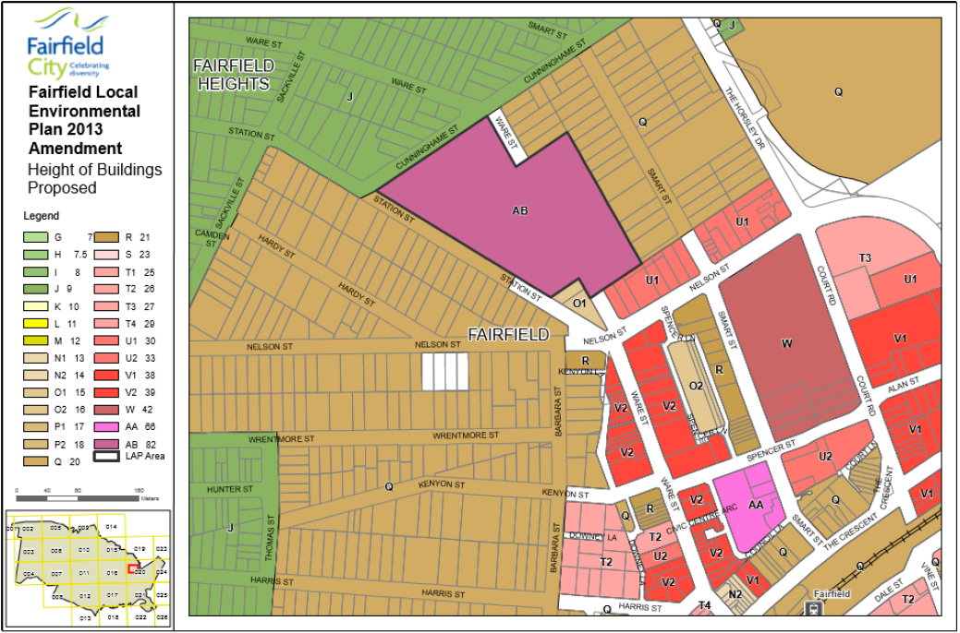

Figure 4 - Proposed Height of Building

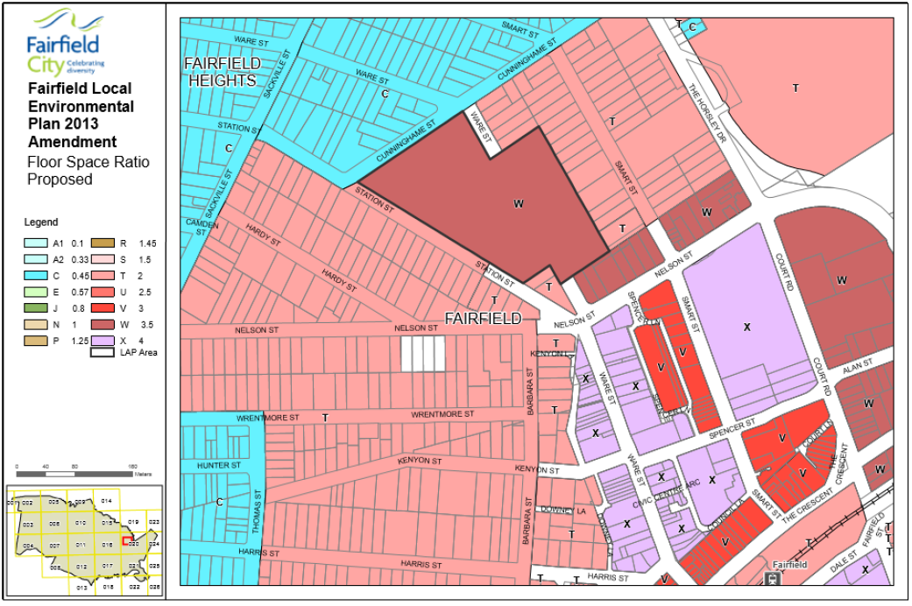

Figure 5 – Proposed Floor Space Ratio

**3. NEED FOR THE PLANNING PROPOSAL**

The planning proposal is the result of the Fairfield City Centre Urban Design Study **(Attachment I)**. The study provided the framework for future development proposals for several key sites greater than 2,500m² in area within the Fairfield Town Centre.

The study identified the site as a key site and recommended a maximum building height of 20 storeys for the site while recognising that additional building height and/or FSR in excess of those recommended in the study could be considered where outstanding design excellence and greater community benefits are proposed. As indicated, the planning proposal seeks to increase the permissible height from 26m (8 storeys) to 82m (25 storeys) and the FSR applying to the site from 2.5:1 to 3.5:1.

The planning proposal is the best and most appropriate means to achieve the intended outcomes.

**4. STRATEGIC ASSESSMENT**

**4.1 District**

Western City District Plan

The Western City District Plan identifies the Fairfield Town Centre as a Strategic Centre. The proposal is consistent with:

*Planning Priority: W3 Providing services and social infrastructure to meet people’s changing needs:*

The proposal seeks to renew and revitalise the Fairfield Forum site developed in 1970’s and 1980’s to a new contemporary centre. It will provide a new type of retail uses, including fine grain retail and food and drink premises, housing diversity and deliver a built form and urban design outcomes with through site links and a series of new open spaces, i.e. a total of 7,900m², including a new 4000m² public park.

*Planning Priority: W4 Fostering healthy, creative, culturally rich and socially connected communities:*

The Landscape and Public Domain Concept Plan **(Attachment J)** proposes a new public park, market square and linkages between civic and landscape spaces, and indoor and outdoor mall areas - to provide a broad range of experiences and identity spaces that together create a rich and diverse public domain for Fairfield Forum. The concept plan aims to encourage a strong social aspect to the retail environment, with the intention of encouraging socialising.

*Planning Priority: W5 Providing housing supply, choice and affordability, with access to jobs, services and public transport*:

The proposal is consistent with a 30-minute city vision of the District Plan. The proposal seeks to provide housing and jobs within 10-minute walk from a major transport interchange.

*Planning Priority: W6 Creating and renewing great places and local centres, and respecting the District heritage*:

The proposal - by delivering new housing, shops, business and services - seeks to act as a catalyst to revitalise the area. The redevelopment of the site will generate new jobs, increase opportunities for investment and business and in return contribute to the local economy.

*Planning Priority: W15 – Increasing urban tree canopy cover and delivering Green Grid connections:*

The Landscape and Public Domain Concept Plan **(Attachment J)** illustrates that the proposed public park, market square and residential courtyards are interlinked with walkways designed with water features, palm groves and other canopy trees throughout the site.

*Planning Priority W18 – Delivering high quality open space:*

The Landscape and Public Domain Concept Plan **(Attachment J)** proposes a high-quality public park to provide a gateway landscape space marking the entry to the town centre as approached from the west (Figure 6). The park will feature large scale palms framing the view to the park and planting along Cunninghame Walk will invite pedestrians to the Market Square.

It is also proposed that the park will provide an interpretive fabric of artworks and text inlays/graphics that speak of the strong social diversity and landscape and cultural heritage of Fairfield. The total open space of 7,900m² is proposed for public benefit on the site.

**4.2 Local**

Fairfield City Centre Urban Design Study

The Fairfield City Centre Urban Design Study (March 2018) **(Attachment I)** was prepared to facilitate revitalisation of the Fairfield City Centre. As part of this Study, the Fairfield Forum site was identified as a key site and one of the largest consolidated sites under single ownership, thus making it a prime candidate for revitalisation.

Council advises that the planning proposal is consistent with the objectives of the study as it has the potential for the Fairfield Forum site to evolve into a mixed-use centre, capable of providing improved retail, residential, community and recreation uses. Council further advises that as the subject land is located near to facilities, services and public transport, it holds strategic importance.

The proponent has been involved in stakeholder meetings with council during the development of the urban design study. The proposed concept design is the result of intensive consultation between the proponent’s urban design consultants and Council’s various teams.

The proposed development controls are more than the maximum building height of 20 storeys identified for the site in the Fairfield City Centre Urban Design Study. Council, however, supported the proposed concept design for the site with FSR of 3.5:1 and 25 storeys (82m). In supporting this increase, it was considered that the proposal will facilitate the revitalisation of Fairfield Town Centre, providing much-needed quality open space and retail offerings, as well as, variety and quality of housing choices within the town centre.

Draft 2040 Fairfield Local Strategic Planning Statement (LSPS)

Council advises that the planning proposal is consistent with the draft LSPS as:

* it will increase housing supply, choice and affordability within the proximity of services, facilities, public transport and open space;
* create additional infrastructure, including a new public open space and plaza, and
* stimulate economic activity and employment opportunities.

Fairfield City Plan 2016-2026

Fairfield City Plan 2016-2026 (the City Plan) contains the Community’s vision, priorities and outcomes for Fairfield City over the next 10 years.

Council advises that the planning proposal is consistent with the relevant goals contained within the City Plan, as it will:

* assist in facilitating a range of housing types to meet the needs of the community in an accessible location;
* provide a variety of shops in the centre;
* generate short term employment through the construction of the project and ongoing employment through retail, services and commercial activity, and

Fairfield Local Planning Panel

The planning proposal was considered by the Fairfield Local Planning Panel on 19 June 2019 **(Attachment M)**. The Panel supported the proposal for the following reasons:

* it has site specific and strategic merit as it is consistent with the planning priorities and actions in the Western City District Plan and objectives of 2016-2026 Fairfield City Plan and Fairfield City Centres Policy 2015;
* it is consistent with the role and function of the existing Fairfield City Centre with the potential to result in positive economic impacts through the renewal of an ageing standalone shopping centre and its immediate environment;
* it will provide a high-quality development that meets the community’s needs, as well as, a variety of job and training opportunities;
* it will provide for a new road connection and a public park in an area significantly undersupplied with accessible open space;
* it realises key urban design framework elements contained within the Fairfield City Centre Key Sites Urban Design Study 2018 for the largest site within the centre; and
* it is once in a life time opportunity to bring about the necessary urban renewal for the City’s oldest and largest centre, which will be guided through a site specific DCP.

However, the Panel also recommended that:

* a draft site-specific DCP is prepared and aligns with the indicative concept scheme;
* Council should not proceed with the proposal unless assurance is provided in regard to vesting of the ownership of the proposed park and the extension of Ware Street in Council;
* high level strategic traffic and pedestrian movement advice be provided by the proponent as to the potential requirement for traffic infrastructure as a result of increased traffic movements; and
* an appropriate level of affordable housing is provided within the development.

The Council Report **(Attachment N2)** notes that the first two recommendations of the Panel will be addressed as a site-specific DCP and local VPA will be prepared. In addition, a revised traffic report was prepared by the proponent and considered to be satisfactory by Council’s Traffic and Transport Division.

However, it is noted that Council has not addressed the affordable housing recommendation of the Panel. Therefore, it is recommended that Council addresses this matter prior to the exhibition of the planning proposal.

**4.3 Section 9.1 Ministerial Directions**

The relevant section 9.1 Directions are as follows:

Direction 1.1 Business and Industrial Zones

This direction aims to encourage employment growth in suitable locations; protect existing employment land; and support the viability of identified strategic centres.

This Direction applies to this planning proposal as it affects B4 Mixed Use zoned land which allows all proposed uses on the site. The planning proposal is consistent with this direction as it retains the existing business zoned land and does not reduce the total potential floor space area for employment uses.

Council also note that the proposal is the result of the Fairfield City Centre Urban Design Study for Key Sites **(Attachment I)** and will introduce new types of retail uses as well as residential dwellings to activate the town centre.

Direction 3.1 Residential Zones

This Direction seeks to encourage a variety and choice of housing types to provide for existing and future housing needs. It also seeks to make efficient use of existing infrastructure and services and ensure that new housing has appropriate access to infrastructure. The Direction applies as the proposal entails significant residential development.

The proposal is consistent with the Direction as it will:

* increase residential dwellings on a site within a town centre, near public transport services;
* broaden the type and choice of residential dwellings; and
* make efficient use of a strategically located site, with existing and proposed infrastructure and services.

Direction 3.4 Integrating Land Use and Transport

The Direction applies to the planning proposal. Under this Direction, a planning proposal must include provisions that give effect to and are consistent with the aims, objectives and principle of Improving Transport Choice – Guidelines for planning and development (DUAP 2001) and The Right Place for Business and Services – Planning Policy (DUAP 2001).

The planning proposal is consistent with the objectives of this Direction as it seeks to improve access to housing, jobs and services by walking, cycling and public transport, and the reducing travel demand including the number of trips generated by development and the distance travelled, especially by car.

The site is within 450m of Fairfield train station and is well serviced by public transport services. It is accordingly anticipated that travel demand, i.e. private car journeys resulting from the increased residential population, will be reduced.

Direction 4.3 Flood Prone Land

This Direction aims to ensure that development of flood prone land is consistent with the NSW Government’s Flood Prone Land Policy and that potential flood impacts are considered.

Council has advised that the site is affected by both overland flow and mainstream flooding. It is partially within the high, medium and low flood risk precincts but confined to lower levels of the south-eastern corner building proposed for retail uses.

The proponent’s Preliminary Flood Investigation (ACOR Consulting, March 2019) **(Attachment G)** for the siteconcluded that:

* the proposed building at the north-east corner will achieve the required Flood Planning Levels, as required by Fairfield City Councils Flood Risk Management Policy;
* the ground floor level of the building should be at RL 12.4 m AHD or greater; and,
* the impact of the proposed development on flooding is minimal and, consequently, the displacement of flooding will have no impact on the adjoining properties or critical areas.

Council advises that future development of the subject site may alter the proposed footprint and a further flood assessment will be required at development application stage in accordance with Clause 6.3 Flood Planning of Fairfield LEP 2013 and the City wide DCP 2013.

The subject land is slightly affected by overland flow and mainstream flooding, however, the impacts of the proposed development on flooding is considered to be minimal. It is considered that any inconsistency of the planning proposal with the direction is of a minor nature and is recommended accordingly.

To ensure that this matter is further considered, however, it is recommended that Council consult the Environment, Energy and Science Group within the Department of Planning, Industry and Environment and the NSW State Emergency Service.

**4.4 State environmental planning policies (SEPPs)**

The planning proposal is generally consistent with all relevant SEPPs.

**5. SITE-SPECIFIC ASSESSMENT**

**5.1 Social and Economic**

The planning proposal will have positive social and economic impacts on Fairfield Town Centre. It proposes to revitalise a site within the town centre through redevelopment and improve the economic viability of businesses in the town centre. The proposal will also provide housing choice, along with recreational and community facilities within the town centre.

**5.2 Environmental**

The site is within an established urban area and does not contain any critical habitat or threatened fauna.

**5.3 Traffic and Parking**

A Traffic and Parking Assessment and Addendum **(Attachments F1 and F2)** was prepared for the proposal. The assessment identified that:

* the proposed 2,919 car parking spaces exceeds the required 2,611 car parking spaces under Fairfield DCP; and
* the additional forecasted traffic generation by the site, mainly from the increased residential development is estimated to be 18%, based on the RMS traffic generation rates.

The report considered the additional traffic generated is relatively minor and is likely to be less than forecasted using the RMS traffic generation rates given the subject site is highly accessible to work, shopping, education and public transport.

In terms of on-site access, the proposal seeks to segregate the traffic and car parking by uses, with residential car parking areas being separated from commercial and retail parking areas. The report further states that loading zones for commercial and retail uses are also configured, as best as practicable, to be designated as such and arranged in a manner to minimise mixing of loading traffic with other uses.

The proposal will provide a new through site road connection by linking Ware Street through the site to Station Street, providing vehicular and services access to new development. No increase to the retail trading area on the site is proposed, however the proposed retail carpark access points are to be enhanced and dispersed around the site. The new residential components of the development are to be provided with separate and independent carpark entry points and loading facilities to reduce conflict with pedestrians.

The report has stated that Council has advised a detailed road network and intersection assessment is to be prepared as part of subsequent development works.

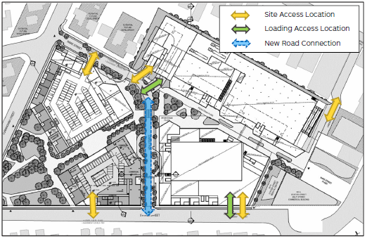

Figure 6 - Proposed site access locations.

Department Comment:

While a traffic and parking assessment has been prepared **(Attachments F1 and F2)**, a detailed road network and intersection study has not been prepared to assess the impacts of the proposed development on the surrounding road network, i.e. the Horsley Drive, a key arterial road and, if needed, identify road infrastructure improvements, i.e. intersection upgrades and road widening.

In light of the proximity of the site from public transport services (i.e. rail and bus services) consideration should be given to the appropriate number of car parking spaces to support the proposed development. However, this is a matter that can be considered by Council at development application stage.

It is accordingly recommended Council prepare a further transport study that appropriately addresses traffic issues and impacts on the surrounding road network, including the need for the upgrading of streets and interactions. Further, it is recommended that Council provide the study in its consultation with the RMS and TfNSW, as part of Agency consultation.

**5.4 Built form and layout**

The proposed indicative layout plan proposes four buildings with residential towers above retail uses, ranging from five to 25 storeys. Higher towers are to be located within the core, transitioning to lower heights towards the edges of the site towards R3 and R4 zoned land and buffered through proposed podium levels and landscaping. Lower buildings with 5 storey heights are proposed along Ware Street, 6 storeys along Station Street and 8 storeys along a new connecting road from Ware Street to Station Street. Refer to Figure 7 for the overall built form.

The masterplan notes that the built form (height and FSR) and orientation of the proposed towers have been designed to optimise solar access on the majority of the site as well as the impact on the surrounding development and open spaces.

The Solar Standards Letter and Peer Review (Ethos Urban, September 2018) **(Attachment H)** states that setbacks to towers and podium heights allow sufficient solar access (measured at 22 June between 9am to 3pm) to the surrounding residential development in accordance with Apartment Design Guide. The placement of the proposed public park to the north-west corner of the site will allow significant buffer to the surrounding urban form and enable maximum daylight access to the residential development along Station Street.

Department Comment:

The Department notes that a shadow diagram has not been prepared for this planning proposal. The overshadowing impacts of the additional height is not illustrated on the site or on the adjacent properties.

It is considered that further information as to the level of solar access received across all future public spaces/open space on the site and adjoining properties is required for the comprehensive assessment of the planning proposal. A Gateway determination condition is proposed to amend the supporting urban design study by including a comprehensive overshadowing diagram that shows shadows cast by the proposed buildings on the existing surrounding development.

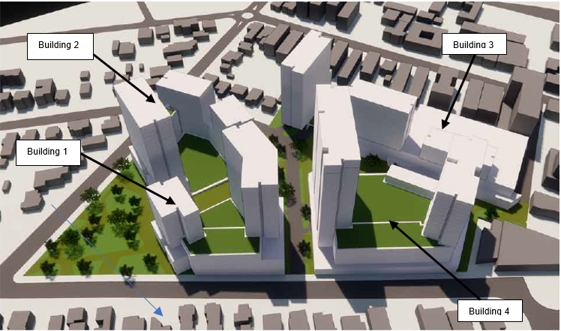

Figure 7 – Proposed built form

**5.5 Open Space**

The key Urban Design Principles for open space in the masterplan (Figure 8) are:

* creating active frontages throughout the project;
* increasing pedestrian connection and activity; and
* activating open spaces through public and private uses.

Council advises the proposed community open space at the corner of Cunninghame Street and Station Street will provide needed open space in the town centre and address the significant undersupply of accessible local open space within Fairfield.

The proposal maximises open space opportunities at nodes along links through site.

The proposed public park to the north of site will provide a community open space at the northern site boundary and create a green gateway to Fairfield. The proposal will facilitate street amenity and extend existing pedestrian linkages through the new centre. This will connect with the town centre through the proposed new link road, Market Square and the mall plaza. The total open space (7,900m²) proposed for public benefit on the site includes:

* a community park - 4,000m²;
* through site links - 1,700m²;
* a market square - 1,000m²; and
* the mall plaza - 1,200m².

Details of the landscape concept is in the Landscape Concept Report **(Attachment J)**.

As noted previously, the open space benefits will be outlined in the local VPA and site-specific DCP. Council will also prepare a separate planning proposal to rezone the open space once it is dedicated to Council as part of this planning proposal process.

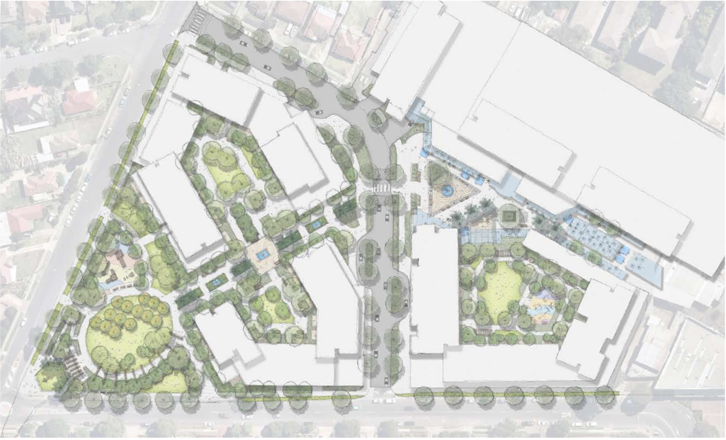

Figure 8 – Proposed landscape masterplan

**5.6 Flooding Impacts**

Preliminary Flood Investigation **(Attachment G)** identified the site being within the Prospect Creek Catchment area. Reference was made to an Overland Flood Study which identified that the subject site is partially within the medium flood risk precinct, being land below the 100-year ARI flood event that is not subject to a high hydraulic hazard (Figure 9).

The site, however, remains largely unaffected by overland flows (Figure 10) except within the southern central portion of the site, which is adjacent to the corner of Nelson, Ware and Station Streets). The consultant confirms that the effect of the proposed development footprint on flooding is minimal, due to the ability of the proposed open space areas to cater for the flood fringe flows and direct water away from site.

The consultant also referred to a Flood Information Sheet issued by Council dated 19 June 2015, and concluded that the area on the site affected by flooding is primarily restricted to the proposed building in the south-east corner of the site, and that the rest of the site remains unimpacted by flooding.

The investigation concluded that:

* the proposed building at the north-east corner will achieve the required Flood Planning Levels, as required by Fairfield City Councils Flood Risk Management Policy;
* the ground floor level of the building should be at RL 12.4 m AHD or greater; and,
* the impact of the proposed development on flooding is minimal; accordingly, the displacement of flood waters will have no impact on the adjoining properties or critical areas.

The investigation further noted that it may be probable that flood freeboard levels will need to be implemented once final development footprints are provided.

Department Comment:

It is considered that Council can address these issues at development assessment stage under Clause 6.3 Flood Planning of Fairfield LEP 2013.

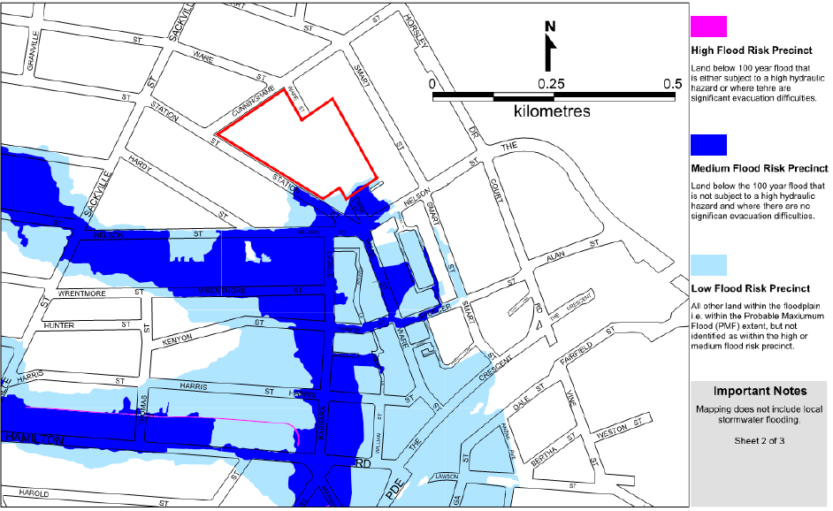

Figure 9 – Flood Planning Map

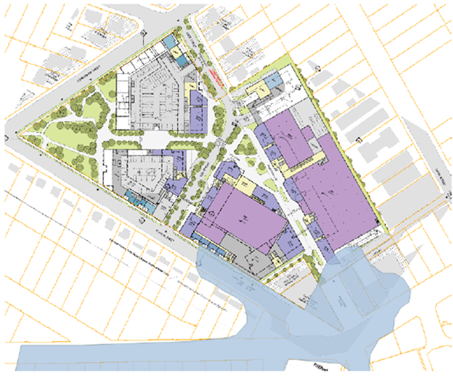

Figure 10 – Flood extent and Masterplan footprint

**5.7 Infrastructure**

The site is currently serviced by all necessary infrastructure and utilities, and consultation is recommended with relevant service providers.

**6. CONSULTATION**

**6.1 Community**

No community consultation period has been proposed by Council. However, given the nature of the planning proposal, it is recommended that it should be placed on public exhibition for a minimum of 28 days.

**6.2 Agencies**

Consultation with Roads and Maritime Services, Transport for NSW, State Emergency Services, the Environment, Energy and Science Group and relevant infrastructure service providers are recommended.

**7. TIME FRAME**

Council proposes a timeframe of 9-months to finalise this planning proposal. Given the nature of the planning proposal, a 12-month timeframe is considered appropriate.

**8. LOCAL PLAN-MAKING AUTHORITY**

Council has requested to be a local plan-making authority to exercise the local plan making function under delegation in relation to this planning proposal. Given the nature of the planning proposal it is recommended that Council be given the delegation to exercise as a local plan-making authority under the section 3.36 of the *EP&A Act*. The local plan-making reporting template is at **Attachment O**.

**9. CONCLUSION**

It is recommended that the planning proposal proceed with conditions. The proposal will revitalise an underperforming town centre and improve the economic viability of the centre - with additional retail opportunities, jobs, new housing type and choice, as well as, recreational and community facilities near public transport services.

**10. RECOMMENDATION**

It is recommended that the delegate of the Secretary:

1. agree any inconsistency with Section 9.1 Direction 4.3 Flood Prone Land is of minor significance.

It is recommended that the delegate of the Minister for Planning and Public Spaces, determine that the planning proposal should proceed subject to the following conditions:

1. Prior to public exhibition, Council is to amend the planning proposal, as follows:
2. under the introduction section of the proposal, clarify whether the proposal will generate any additional jobs;
3. where appearing, remove references to redundant section(s) of the Environmental Planning and Assessment Act and replace with the current section(s) and reference to redundant departmental guides (refer to page 3 of the proposal); and
4. amend the supporting urban design study by including an overshadowing diagram that clearly shows shadows cast by the proposed buildings on the existing surrounding development;
5. prepare a draft site-specific DCP aligned with the proposed indicative concept plan and exhibit the draft DCP with the planning proposal;
6. the draft site specific DCP is to address, but not limited to, identification of the open space areas (proposed park) and a note indicating that Council intends to rezone this land to RE1 Public Open Space, as a separate and later matter;
7. prepare a transport study to assess and identify the impact of the planning proposal on the surrounding road network and clarify whether there is a need for infrastructure improvements to accommodate the additional traffic generated by the planning proposal; and
8. remove the proposed Land Application Map from the planning proposal.
9. Public exhibition is required under section 3.34(2)(c) and Schedule 1 Clause 4 of the Act as follows:
10. the planning proposal is classified as low impact as described in *A guide to preparing local environmental plans* (Department of Planning, Industry and Environment 2016*)* and must be made publicly available for a minimum of **28 days**; and
11. the planning proposal authority must comply with the notice requirements for public exhibition of planning proposals and the specifications for material that must be made publicly available along with planning proposals as identified in section 6.5.2 of *A guide to preparing local environmental plans* (Department of Planning, Industry and Environment, 2018).
12. Consultation is required with the following public authorities and organisations under section 3.34(2)(d) of the Act and/or to comply with the requirements of relevant section 9.1 Directions:

* Roads and Maritime Services;
* Transport for NSW;
* State Emergency Services;
* Environment, Energy and Science Group; and
* relevant infrastructure service providers.

Each public authority/organisation is to be provided with a copy of the planning proposal and any relevant supporting material and given at least 21 days to comment on the proposal.

1. A public hearing is not required to be held into the matter by any person or body under section 3.34(2)(e) of the Act. This does not discharge Council from any obligation it may otherwise have to conduct a public hearing (for example, in response to a submission or if reclassifying land).
2. The planning proposal authority is authorised as the local plan-making authority to exercise the functions under section 3.36(2) of the Act subject to the following:
   1. the planning proposal authority has satisfied all the conditions of the Gateway determination;
   2. the planning proposal is consistent with section 9.1 Directions or the Secretary has agreed that any inconsistencies are justified; and
   3. there are no outstanding written objections from public authorities.
3. The timeframe for completing the LEP is to be **18 months** from the date of the Gateway determination.



**Terry Doran**

**Acting Director Western**

**Central River City and Western Parkland City**

Assessment officer: Amar Saini/Cho Cho Myint

Western

Phone: 9373 2880/98601507